How to complete the government’s online calculator for switching to a heat pump

- Visit this website: https://www.heat-pump-check.service.gov.uk/
- Enter your postcode
- Follow the steps until you reach the ‘Results Overview page’:

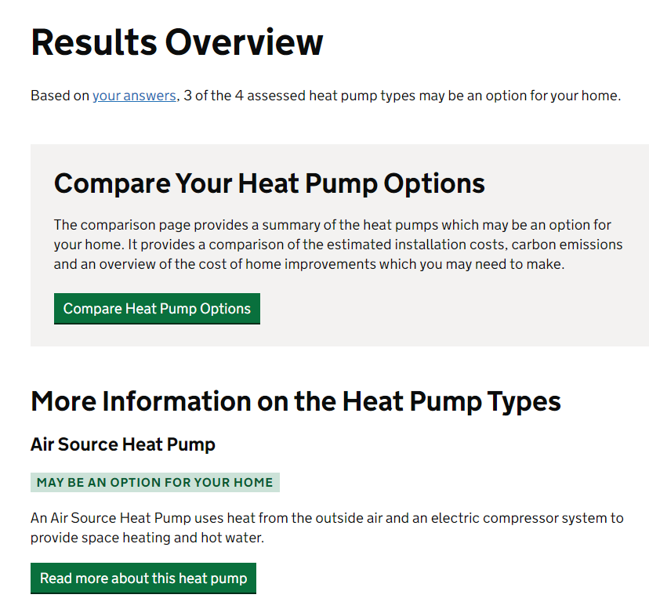

- Click on ‘Compare Heat Pump Options’

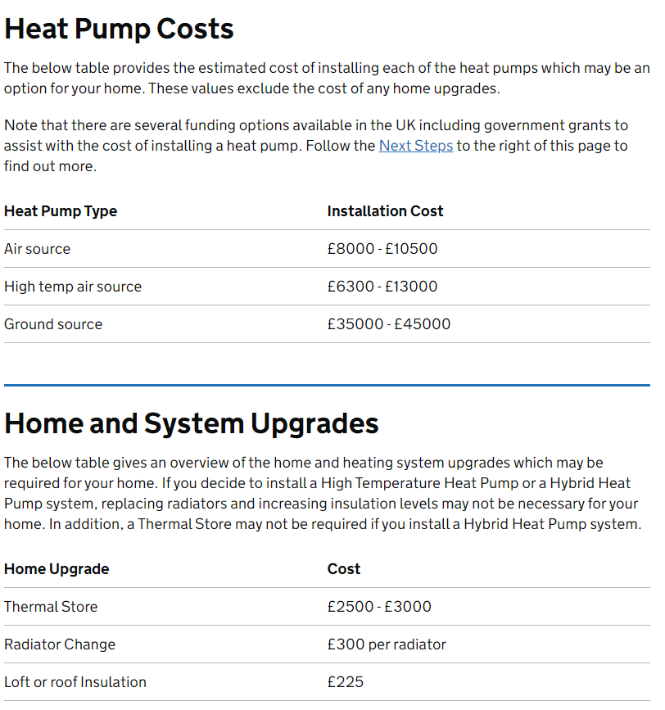

- Under the ‘Heat Pump Costs’ section, make a note of the ‘Air Source’ cost
  - Iin the above example this is £10,500
- Under the ‘Home and System Upgrades’ section, make a note of all the costs
  - In the above example this is:
    - £3,000
    - £300 per radiator (if you have 12 radiators this would be £3,600)
    - £225
- Add the above figures together
  - In the above example this would be £17,325 (£10,500 + £3,000 + £3,600 + £225)
- Add this figure into the second paragraph of the letter here: £xxx.

